Hispanic STEM Initiative Update
Tuesday, October 18, 2011

Dear Friends,

Fall is in the air, the academic year is well underway, and cities, towns and communities across the country have just concluded commemorating Hispanic Heritage Month – a time to acknowledge the wealth of contributions that Hispanic Americans have made to the nation. And these contributions are substantial and pervasive in such fields as agriculture and ranching, medicine and transportation, and music and culture. (See excerpt of remarks below delivered to the U.S. Marshalls on September 27, 2007 in Washington, D.C.) As Hispanic Americans, our roots here run deep and for more than two centuries we have helped to build this great nation and have upheld a strong tradition in responding to calls for its defense in every war dating back to the Revolutionary War.

Today, our nation is calling on us again – to help build, develop, and produce the STEM talent on which it will depend to restore its competitiveness and leadership in the global economy. I am confident that we can respond to this new call. I believe that we must, especially in the middle of the economic malaise in which we find ourselves. The consequences for our children, our community, and our nation are too ominous to do otherwise. And, we cannot afford to wait or rely on the “same old, same old.” Instead, bold new collaborative steps and efforts grounded on evidence are needed to substantially increase positive education outcomes for Hispanic students in the STEM disciplines. As most of you know, such a STEM alliance is already underway in America, through the tireless work that many of you are conducting as part of the network of stakeholder groups and organizations that comprise the Hispanic STEM Initiative. We will rely on such an alliance to draw on the best of your experience, hard work, and success – assets that will help form what may be the largest contribution we will have made to our nation in this century.

In connection with this STEM alliance, I am proud to announce that some of the nation’s most experienced and dedicated leaders in STEM education in America were installed on the Hispanic STEM Initiative’s Board of Directors. The board held its first in-person meeting in Oakland, California, since obtaining our tax-exempt status this past summer. (Previously, the Hispanic STEM Initiative had been serving under the umbrella of the International Center for Higher Education and Philanthropy.) I hope you will join me and these leaders in responding to the nation’s call to forge a transformative legacy in STEM education for our children and the nation that they will inherit in the future.

Newly-installed members of the Board of the Hispanic STEM Initiative.
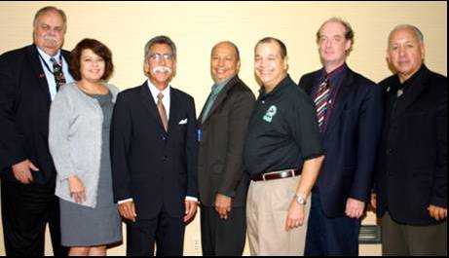
Pictured L to R: Dr. Oscar Porter, MESA; Maria Lopez, El Valor, Adam Chavarria, Hispanic STEM Initiative, President; Dr. Rudy Reyna, PREP-USA, Treasurer; Mike Acosta, MAES, Chairman; Dr. Michael Marder, UTeach; David Valladolid, PIQE. (Not pictured is Nora Ramirez, Jorge Haynes, and Diana Gomez.) Photo courtesy of Lynne Andrews, MAES MAGAZINE LAM DESIGN, LLC

News, Information, and STEM Articles of Interest
As a regular feature of the Hispanic STEM Initiative Update, I am pleased to provide you the following news, information, and articles of interest in STEM education. I especially thank Dr. Refugio Rochin, David Valladolid, and those of you who submitted some of this information and encourage the rest to do same when you encounter an educational item that will be of interest to the network.

PARENT AND FAMILY INVOLVEMENT

Adam: Below is a powerful presentation by a PIQE Father at his graduation. As you may know, each PIQE class selects one parent to give a testimony at their PIQE graduation. I’m sure you will agree with me that the testimony below is a beautiful and incredible presentation by this Father. He delivered his speech in both English and Spanish. It’s these testimonies that keep us going and make us realize the impact we are having on the parents we have the honor to serve and educate on their roles in the education of their children. Thank you for your ongoing support and guidance! David Valladolid

PIQE GRADUATION: La Academia Centro Vida and The Bay Area Hispano Institute for Advancement, Inc. (BAHIA) collaborated to host the PIQE workshops.

Graduation date: Saturday, June 11, 2011 & the PIQE Father is Mr. Juan M. Davila.

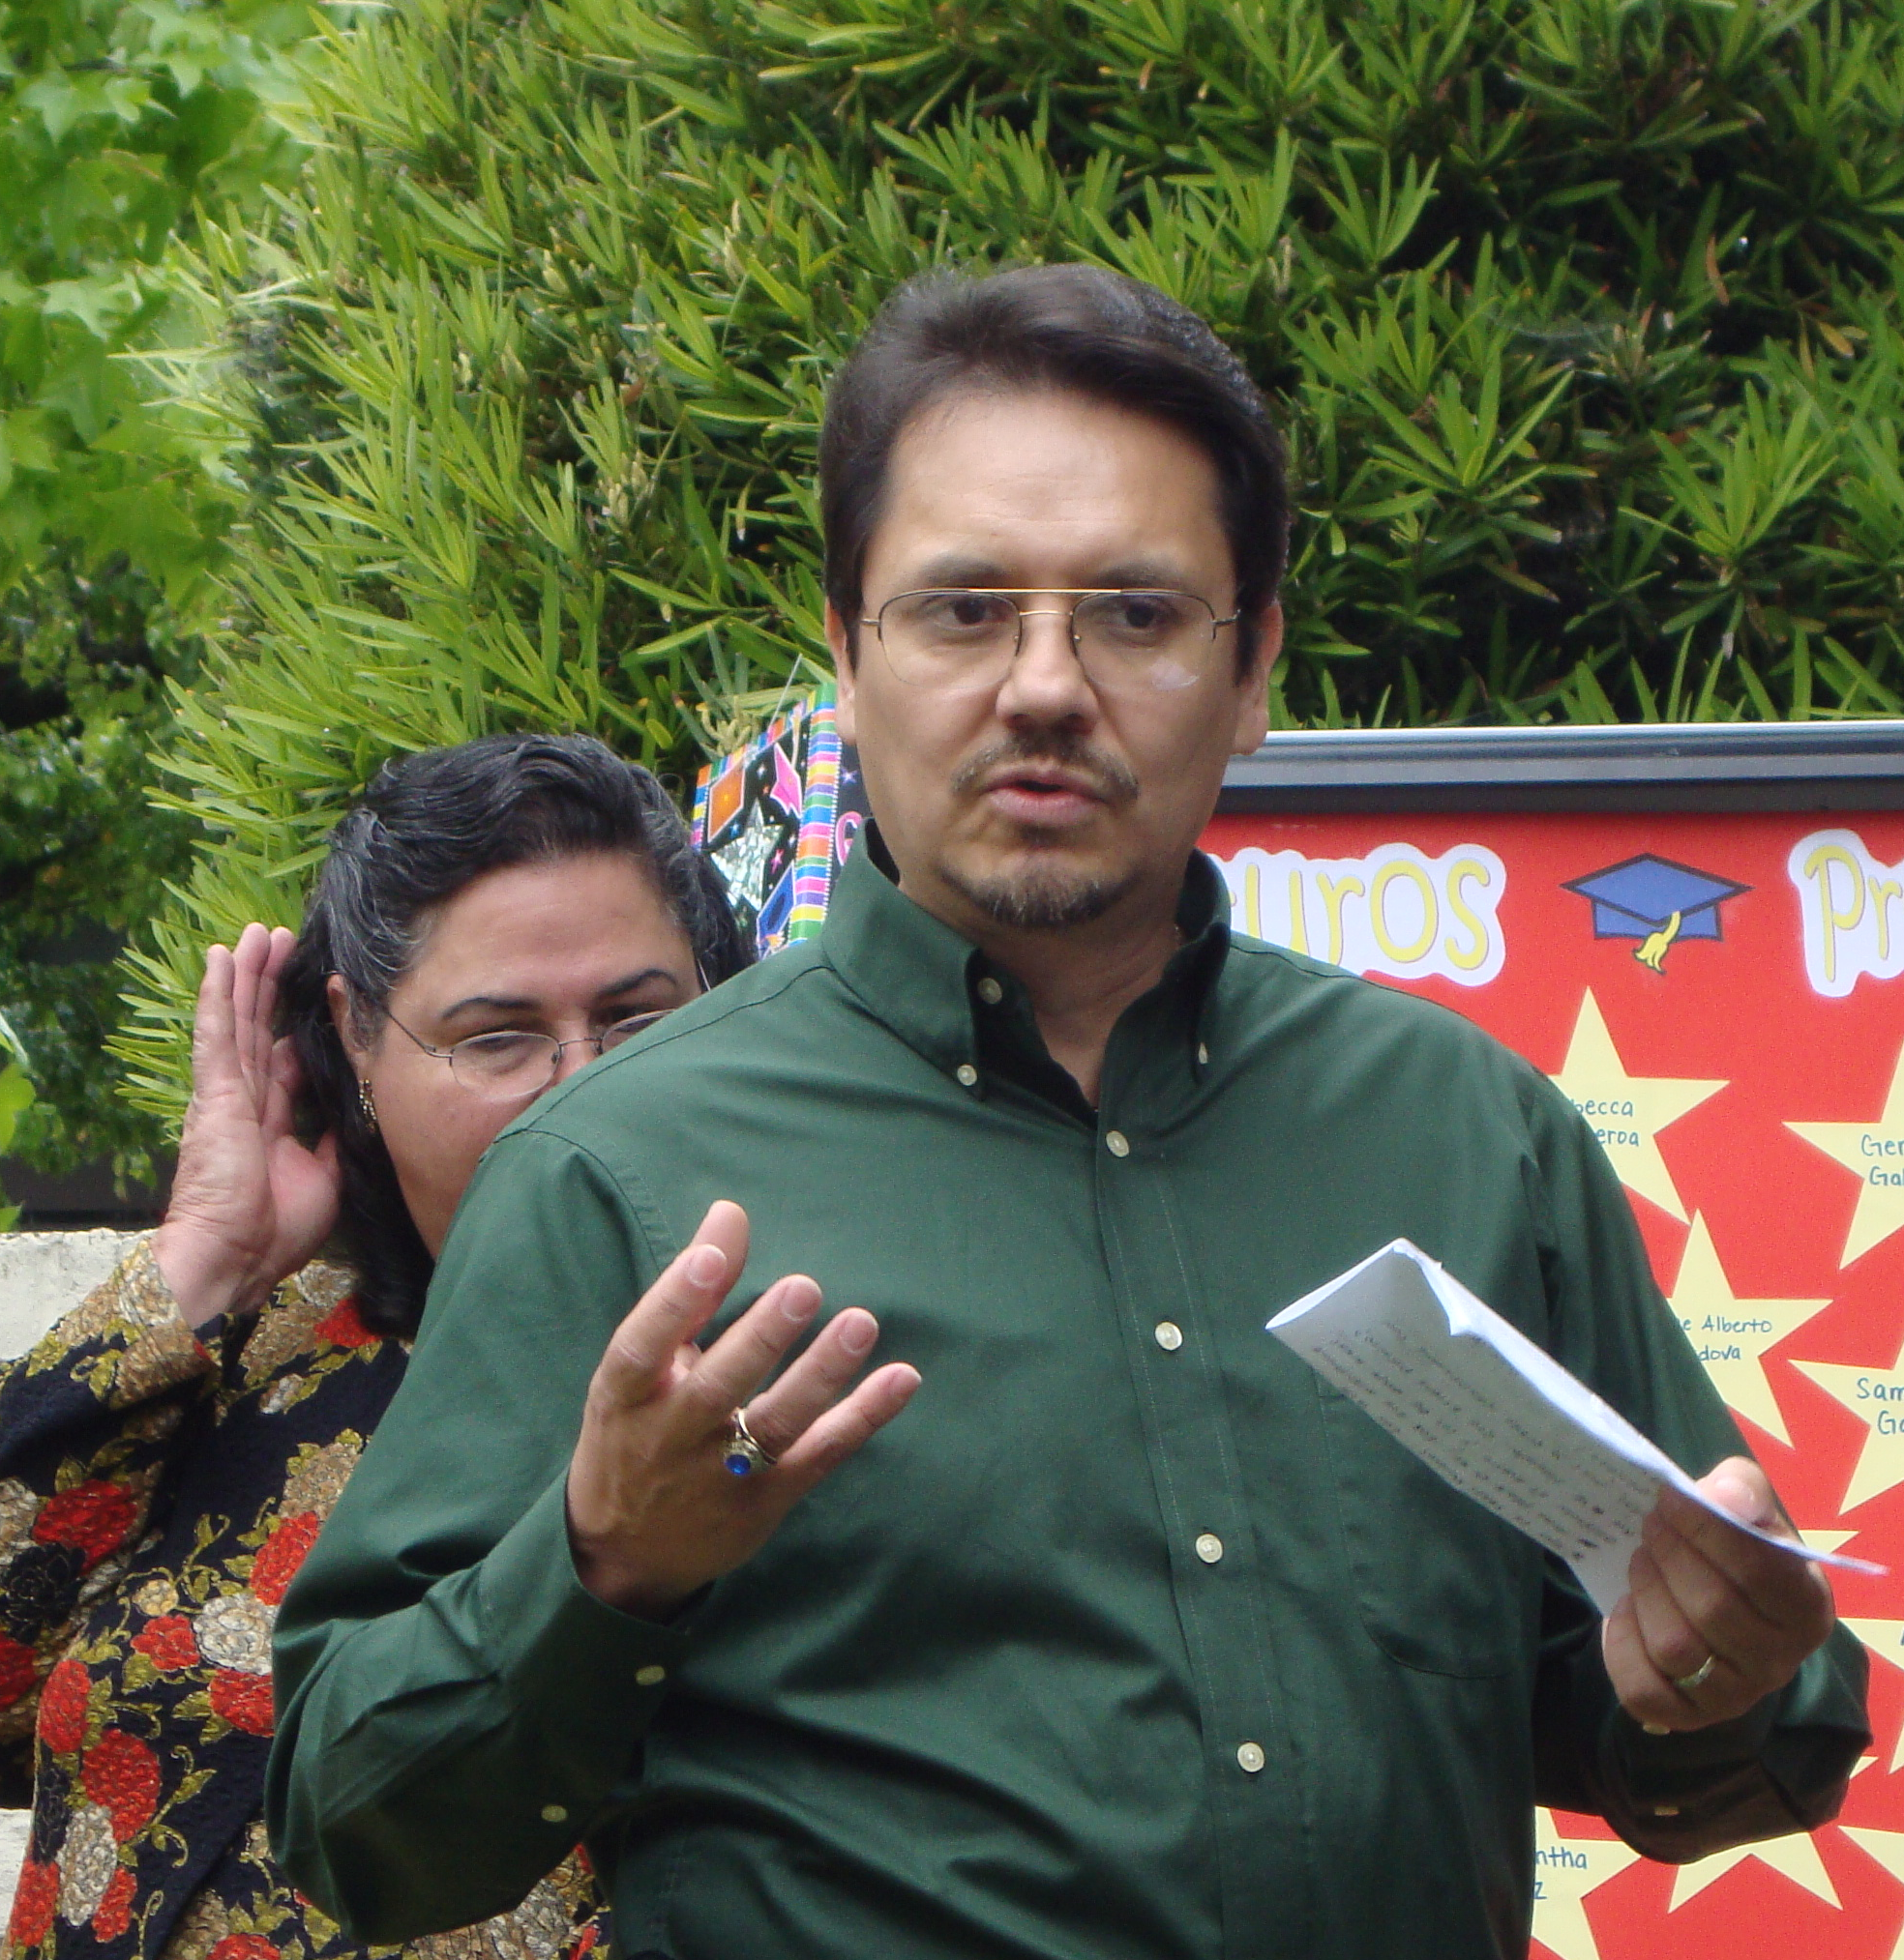
“Good morning!

How many of us are going to support our children to go to University? Please raise your hand!

First, I want to give my deepest thanks to all parents who voted for me to be the bearer of a very important message. A message of gratitude and satisfaction for everything we've learned about the mental and educational development of our beloved children.

The national program, PIQE, really is the light at the end of the tunnel that many parents are looking for when it comes to supporting our children towards a successful educational future.

Life for me is like a parade. There are 3 types of people: Those who participate in it, those who closely watch the event and those who stand all the way in the back asking ... ... what is happening? Well, I want to identify with the first and I think you do too. The proof is here with your presence.

In these very difficult and competitive times, we cannot sit back and follow the rest. We must be leaders like Mildred, Martha Cueva, Minerva Perez, and David Valladolid, President of PIQE. We also need to commit ourselves to adopt an attitude of constant involvement, supporting and motivating our children to develop good study habits and focus.

It is noteworthy to mention that even when we won’t be able to help them with a difficult assignment, a complicated subject like Trigonometry, we are very fortunate to live in the era of technology, the computer, the Internet. We can use the internet to at least guide them to a website where they can find the right answers. There are no excuses!

On the other hand, I want to give an advice to Latino men like me. We need to recognize the great work that our women do with our children. Many of them work hard during the day and when they come home, prepare our food, wash our clothes and care for our children. We should abandon the machismo that still remains, walk beside them and spend more time with our children! I think we are succeeding at this, and the proof is here with all the men present.

Reading the comments and feelings of parents graduating today from the PIQE program, I noticed a common denominator in their thoughts: That we are parents who do not want our children to suffer the same way we have! We want the best for them. Do you agree? They are the most valuable jewel we have in that well kept treasure chest , they’re like a diamond in the rough that we need to cut to perfection if we can, and polish it so it shines!

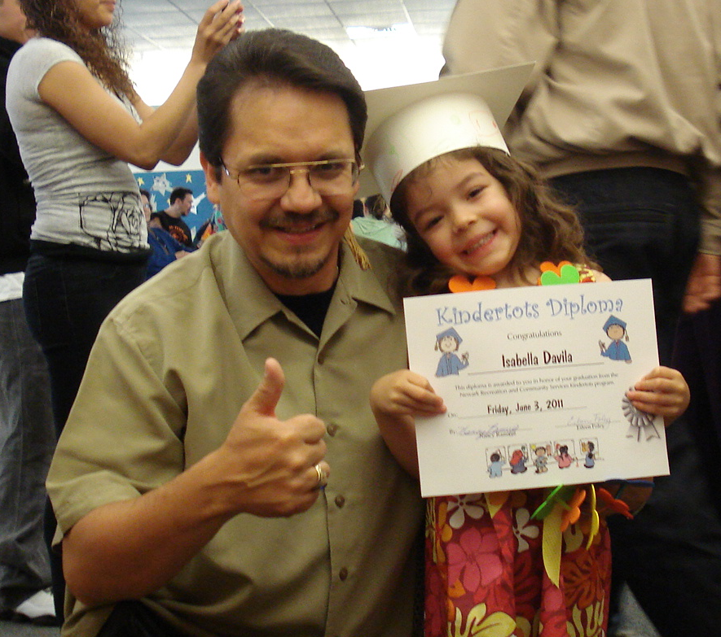
Also, that from now on we will support, motivate and be present in their schools until we see that University diploma in their hands ... ... in our hands! Through PIQE, the University has ceased to be something unreachable for our children. PIQE Thanks! For the time you have invested in us, and for having faith in us. PIQE Thanks! For giving us the necessary tools to support our children to build a solid foundation in their education.

A million Thanks for giving us the key that opens the door to success in school! It is time! And "Yes we can!”

I would also like to specially thank the following people, who have made it possible for us to immensely benefit and spread PIQE’s message, its teachings and its mission to our community. I ask for a big round of applause please for:

Karyn Barnes, Senior Associate FIRST 5 program.
Beatriz Leyva-Cutler, Executive Director of BAHIA Inc.
Martha Cueva, Executive Director-PIQE program.
Minerva Perez, Principal at Academia de Centro Vida

To teachers: Bertha and Rosa (Star group) because it is the group of my daughter Isabella. All teachers and staff of Little Mud Puddles and Academia de Centro Vida. And above all, an Angel who is here in disguise ... ... Mildred Dumeng, For her hard work, her immense knowledge, her leadership and last but not least,... .. For her beautiful smile and very positive attitude!

Thank you very much.”

ACADEMIC PREPARATION

Recent High School Grads Regret Class Selections
By Jason Koebler
U.S. News & World Report
Posted August 30, 2011 01:28 PM ET

Recent high school graduates agree that college is important. According to a survey of 2010 high school graduates released by the College Board today, 90 percent said that their high school diploma was not enough to compete in today's society.

The organization, which administers the SAT and Advanced Placement (AP) exams, checked in with 1,507 students who graduated from high school in 2010 to see how they were doing a year later. Most of them are faring well; three quarters said they had a "good" or "great" 2010, and only 9 percent said they were dissatisfied with their high school experience.

But almost half of students say they wish they took different classes in high school, particularly more difficult science, math, and writing courses. Students who did challenge themselves by taking AP or International Baccalaureate courses—39 percent of those surveyed—say the extra difficulty was worth it. An overwhelming majority of those students say AP and IB courses were more worthwhile and more interesting than their standard coursework.

College Board officials say that high schools need to find a way to encourage students to take more difficult classes before it's too late.

"Students are asking for more rigor after they're out of the frying pan, and have been dropped into a larger frying pan," Trevor Packer, College Board's senior vice president for AP and college readiness, said during a conference call with media.

In hindsight, many students agree; 37 percent of 2010 graduates say that high school graduation requirements should be made tougher, and nearly 70 percent said that graduating from high school was "easy" or "very easy."

Some students say high school didn't adequately prepare them for college; 54 percent of graduates say that their freshman year college courses were more difficult than expected, and a quarter needed to take remedial coursework during their freshman year. One in seven students dropped out during their first year of college.

Among the 26 percent of graduates surveyed who did not enroll in a post-secondary program, 83 percent say they want to complete a college degree in the future. Graduates who didn't attend college say they wanted to take time off from school, couldn't afford school, or were more interested in working than attending school.

http://www.usnews.com/mobile/blogs/high-school-notes/2011/8/30/recent-high-school-grads-regret-class-selections.html

California’s Math Pipeline: The Grade 7 Pivot Point
EdSource
September 2011

For students to be career- and college-ready when they complete high school, they must build a strong base of mathematics knowledge. The end of 7th grade provides an important moment to assess how prepared California’s students are to succeed in the more advanced math curriculum that starts with algebra.

California’s 1997 academic content standards in mathematics outline the stepping stones to algebra, and the Grade 7 Mathematics California Standards Test (CST) provides a benchmark measure of students’ readiness.

In addition, 7th grade is the point where students’ math course-taking paths clearly begin to diverge:

- A small group of the most advanced 7th graders take Algebra I.
- More than half of students will take Algebra I in 8th grade, with mixed success.
- Another large portion will not be placed into a full Algebra I course—or otherwise complete the course—until 9th grade or later.

All of these students will be tested on 7th grade math content again, however, and their high school success depends on mastering it early.

- Those who do not take a full Algebra I course in 8th or 9th grade will take the General Mathematics CST, which tests mostly 7th grade content.
- All students will be tested on primarily 7th grade math content when they take the California High School Exit Examination (CAHSEE), which they must pass to get a high school diploma.

At a minimum, all California students are required to successfully pass Algebra I in order to receive a high school diploma. But Algebra I also functions as the gateway to more advanced math and science coursework. Where students stand at the end of 7th grade determines how quickly and successfully they get through that gateway.

That makes 7th grade math an important pivot point in the K–12 math pipeline. If California is going to increase the number of students who can succeed in
sophisticated math and science courses in high school—and effectively pursue STEM degrees and careers after graduation—it must improve and accelerate many students’ mathematical skills and understanding through 7th grade.

EdSource's new 4-page issue brief, California's Math Pipeline: The Grade 7 Pivot Point.

U.S. SAT reading scores fall to lowest level on record
Associated Press
Posted September 14, 2011 at 10:32 a.m.
Corpus Christi Caller Times

Scores on the critical reading portion of the SAT college entrance exam fell three points to their lowest level on record last year, and combined reading and math scores reached their lowest point since 1995.

The College Board, which released the scores Wednesday, said the results reflect the record number of students from the high school class of 2011 who took the exam and the growing diversity of the test-taking pool particularly Hispanics. As more students aim for college and take the exam, it tends to drag down average scores.

Still, while the three-point decline to 497 may look small in the context of an 800-point test, it was only the second time in the last two decades reading scores have fallen as much in a single year. And reading scores are now notably lower than scores as recently as 2005, when the average was 508.
Average math scores for the class of 2011 fell one point to 514 and scores on the critical reading section fell two points to 489.

Other recent tests of reading skills, such as the National Assessment of Education Progress, have shown reading skills of high-school students holding fairly steady. And the pool of students who take the SAT is tilted toward college-goers and not necessarily representative of all high school students.
But the relatively poor performance on the SATs could raise questions whether reading and writing instruction need even more emphasis to accommodate the country's changing demographics.

Roughly 27 percent of the 1.65 million test-takers last year had a first language other than English, up from 19 percent just a decade ago.
Jim Montoya, vice president of relationship development at the College Board, said the expanding Latino population was a factor, as well as greater outreach to get minority students to take the test. But there are others, too.

"It's a lot of little things," he said. For example, he said, the number of black students taking a solid core curriculum - a strong predictor of success on the test has fallen from 69 percent to 66 percent over a decade.

http://www.caller.com/news/2011/sep/14/us-sat-reading-scores-fall-lowest-level-record/

Microsoft Releases National Survey Findings on How to Inspire the Next Generation of Doctors, Scientists, Software Developers and Engineers
New survey among college students and parents of K–12 students provides implications for nurturing interest in science, technology, engineering and math (STEM) careers.

REDMOND, Wash. — Sept. 7, 2011 — Microsoft Corp. today announced the findings of two national surveys, conducted online by Harris Interactive, of college students currently pursuing science, technology, engineering and math (STEM) degrees and of parents of K–12 students. The goal of the surveys was to gain insight about what can better prepare and inspire students to pursue post-secondary education in STEM subjects.

The state of STEM education has been a leading topic of conversation and concern among education leaders, teachers and faculty members, policymakers, business leaders, parents, and even students in recent years. The U.S. will have more than 1.2 million job openings in STEM-related fields by 2018, according to the U.S. Department of Labor, and, unfortunately, there will be a significant shortage of qualified college graduates to fill them.

“In today’s globally competitive and technologically driven economy, the jobs available to our country’s young people increasingly depend on the quality of the education and skills they acquire,” said Brad Smith, Microsoft’s general counsel and senior vice president. “If our students are to compete successfully for the jobs of the future, we must better prepare them to be lifelong learners and give them a strong foundation in science, technology, engineering and math. Our goal in fielding the surveys was to uncover ways to encourage interest in STEM among today’s youth — our future leaders.”

Microsoft STEM Survey Key Findings

Parent Perceptions:

Parents were asked about their perceptions of STEM education in K–12, and the survey found broad agreement that there is room for improvement.
- Although most parents of K–12 students (93 percent) believe that STEM education should be a priority in the U.S., only half (49 percent) agreed that it actually is a top priority for this country.
- Parents who feel STEM should be a priority said they feel this way because they want to ensure the U.S. remains competitive in the global marketplace (53 percent) and to produce the next generation of innovators (51 percent); fewer said it’s to enable students to have well-paying (36 percent) or fulfilling careers (30 percent).
- Even though many parents (50 percent) would like to see their children pursue a STEM career, only 24 percent are extremely willing to spend extra money helping their children be successful in their math and science classes.

Student Perceptions

College students pursuing a STEM degree were asked to rate how well their K–12 education prepared them for their college courses in STEM, and why they chose to pursue a STEM academic path.

Importance of K–12 education: For many, the decision to study STEM starts before college.
- Nearly four in five STEM college students said they decided to study STEM in high school or earlier (78 percent). One in five (21 percent) decided in middle school or earlier.
- More than half (57 percent) of STEM college students said that before going to college, a teacher or class got them interested in STEM (20 percent).
- This is especially true of female students (68 percent versus 51 percent of males) who chose “a teacher or class” as the top factor that sparked their interest.

Preparedness:
- Only one in five STEM college students felt that their K–12 education prepared them extremely well for their college courses in STEM.
- Students who felt less prepared for STEM college courses said that offering more STEM courses and having better or more challenging courses would have helped to better prepare them — and for students who felt extremely or very well-prepared, it was the challenging, college prep courses that helped to prepare them.
- Females in STEM were more likely than males to say they were extremely/very or well-prepared (64 percent versus 49 percent) by their K–12 education, and females were slightly more likely than their male counterparts to say that preparing students for STEM should be a top priority in K–12 schools (92 percent vs. 84 percent).

Motivation:

Based on the college student survey findings, the motivation to pursue STEM studies did not originate from their parents telling them to select that subject area or even because they know the U.S. is in need of STEM graduates.
- Rather, students who select a STEM path indicated they do so to secure their own futures.
- 68 percent said they want a good salary.
- 66 percent said it’s the job potential.
- 68 percent said they find their degree program subjects intellectually stimulating and challenging.

Gender differences:

The inspiration for choosing STEM varied quite a bit between males and females.
- Male students were more likely to pursue STEM because they have always enjoyed playing with games and toys, reading books, and participating in clubs focused on their chosen subject areas (51 percent versus 35 percent of females).

http://www.microsoft.com/Presspass/press/2011/sep11/09-07MSSTEMSurveyPR.mspx?rss_fdn=Press%20Releases

New STEM Schools Target Underrepresented Groups
By Erik W. Robelen Education Week
Published Online: September 13, 2011

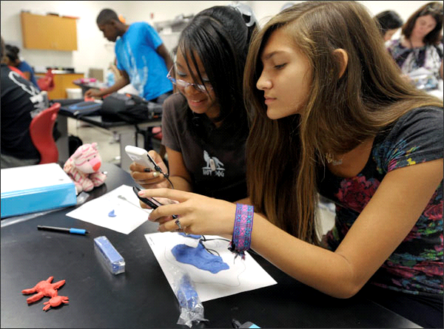
Zipporiah Bush, left, and Sadie Lisk photograph clay creations during a science and engineering class at a STEM-focused high school on the campus of North Carolina State University. It's one of a new crop of schools reaching out to populations that are underrepresented in the STEM fields.
—Sara D. Davis for Education Week
Raleigh, N.C.
Few Americans may know about the Grand Challenges for Engineering—from making solar energy affordable to ensuring access to clean water—but the students at a new school on the campus of North Carolina State University are getting to know them firsthand.
The set of 21st-century challenges, devised by the National Academy of Engineering, serves as a frame and inspiration for the curriculum at this school, one of a relatively small but rapidly growing number of STEM-focused schools cropping up across the country.

At a time of heightened national attention to improving education in the fields of science, technology, engineering, and mathematics, the development of such schools has gained momentum as a strategy to boost knowledge and interest in the subjects.
While STEM schools historically have tended to target the top math and science students in a state or district, the new wave appears to have a broader reach, with many of the schools aimed especially at serving groups underrepresented in the STEM fields, such as African-American, Hispanic, female, and low-income students.

Just this academic year, new STEM schools have opened in a number of states, including Arizona, New York, North Carolina, and Tennessee.
The school at N.C. State, a partnership between the university, the 147,000-student Wake County district, and the nonprofit North Carolina New Schools Project, stresses project-based learning and the integration of topics across content areas.

In its first year, the school identified five of the 14 Grand Challenges for Engineering as the connective curricular tissue.
“By doing a thematic approach, I think you can hook the kids,” said Principal Rob Matheson. “The kids can get into solving challenges. ... They’re really global issues, like access to clean water.”

At a ribbon-cutting ceremony last month, Lt. Gov. Walter H. Dalton, a Democrat, made clear that the school has ambitions beyond its walls. “You’re going to be an anchor school,” he said. “You’re going to be a model for others.”

‘A Term of Art’
Creating STEM-focused schools is not a new idea. Some of the oldest campuses with a math and science emphasis date back decades, such as Stuyvesant High School and the Bronx High School of Science in New York City. The Illinois Mathematics and Science Academy is celebrating its 25th anniversary.
Experts say these highly selective schools play an important role in nurturing top talent, but that a vital national challenge—and an economic imperative—is casting a far wider net to develop talent that might otherwise not be tapped.

“There is a large interest and achievement gap ... in STEM,” said the President’s Council of Advisors on Science and Technology in a report last year that called for 1,000 new STEM-focused schools over a decade. “The underrepresentation of minority groups and women in STEM denies science and engineering the rich diversity of perspectives and inspiration that drive those fields.”

There is not necessarily an agreed-upon definition for a STEM school.

“ ‘STEM school’ is a new term of art,” said Karl T. Rectanus, the leader of the NC STEM Community Collaborative, a public-private partnership in Raleigh that promotes effective STEM education.

“There are schools that define it very differently,” said Barbara Means, a researcher at SRI International who studies STEM schools.

Some, she said, simply bring a more intensive approach to a traditional curriculum, beefing up the offerings and requirements in science, math, and related subjects. Others emphasize project-based learning and integrating ideas across disciplines. Still others may focus on a particular occupational theme, such as biotechnology.

Ms. Means and others warn, however, that some schools may add the label without making real changes.
“A commonality is there needs to be more STEM learning opportunities than in a conventional school,” Ms. Means said. “There needs to be a richer set of resources and a requirement that goes beyond the minimum in math and science.”

Although there’s no official count of STEM schools, an SRI report identified 315 such public high schools as of the 2007-08 academic year.
Some states, including North Carolina, are making the growth of STEM schools a key part of their strategy to improve math and science education and better prepare students for the workforce.

In its successful bid for a federal Race to the Top grant, the state outlined plans to establish four STEM “anchor schools” to provide exemplary curriculum, serve as sites for leadership academies and teacher professional development, and be “test beds for innovation.”

June Atkinson, the state superintendent, tied the effort to economic development and ensuring the state can compete globally.
“Many of the careers our students will have will need a good foundation in math and science and technology,” she said.

The STEM school at N.C. State University has just 55 students, all 9th graders, but will add another grade each year. It’s also an early-college high school, with a five-year program allowing students to earn both a high school diploma and two years of college credit.

To apply to the Wake-N.C. State University STEM Early College High School, students must write two essays—one describing a STEM-related experience—and supply three recommendations, said Principal Matheson. Grades and standardized-test scores are also reviewed. Any Wake County student may apply, he said, but the goal is not to recruit top math and science students.

“Our target groups are underserved, underrepresented [populations],” said Mr. Matheson.

About 70 percent of students are minorities (mostly African-American), half are girls, and 43 percent will be the first in their family to attend college, he said. Forty-five percent are eligible for a free or reduced-price lunch.

Students attend a daily seminar, plus three, 90-minute courses: a hybrid earth sciences and engineering class; Integrated Mathematics 1; and Humanities 1, a hybrid of English and world geography.

http://www.edweek.org/ew/articles/2011/09/14/03stem_ep.h31.html?tkn=WOCCRf/VSK9/FpTBXVLPsvN8femsPBXNSN0l&cmp=clp-sb-ascd

THE ECONOMY AND GLOBAL COMPETITIVENESS

National Experts See a Critical, Growing Connection Between Higher Education and U.S. Economy
Lumina Foundation
August 5, 2011

NEW YORK CITY, N.Y., August 5, 2011—As millions of students prepare to return to college, a new study by the Georgetown University Center on Education and the Workforce confirms that the value of college degrees is increasing. Experts from Georgetown and Lumina Foundation say that postsecondary education has become the new gateway to the middle class and one of the most important economic issues of our time.

According to the study, individuals with a bachelor’s degree now make 84 percent more over a lifetime than those with only a high school diploma, up from 75 percent in 1999. Today, bachelor’s degree holders can expect median lifetime earnings approaching $2.3 million. By comparison, workers with just a high school diploma average roughly $1.3 million, which translates into a little more than $15 per hour.

“On average, people with more education and higher attainment make more than people with less education,” said Anthony P. Carnevale, the Center’s director and co-author of the report. “But, major and occupation matter just as much as degree level. For example, 28 percent of people with an Associate’s degree make at least as much as the average Bachelor’s degree holder—mostly due to occupational choice.”

The release of the report comes as some experts are asking if the rising cost of college has created a higher education bubble. But, in addition to creating opportunities for significantly greater individual earning power, increased college attainment is also quickly becoming one of the key drivers for our nation’s economy.

“The vast majority of new jobs require higher skills and if you don’t have a college degree, your chances of being in the middle class are visibly diminished,” said Jamie P. Merisotis, president and chief executive officer of Lumina. “There is a high probability that you’ll be poor without some form of postsecondary education and that makes education one of the most critical factors in our nation’s long-term economic growth plans. A dramatic increase in educational attainment must become a top national priority if we intend to build our labor pool and beat out other countries for the jobs of the future.”

In a separate study, the Center at Georgetown estimated that by 2018, 63 percent of U.S. jobs will require some form of postsecondary education or training. Unfortunately, we are woefully unprepared for this reality as a nation. Today, approximately 41 percent of adults have a college degree in America.
“Many other countries are faring much better,” said Merisotis. “South Korea, for example, currently has a postsecondary degree attainment rate of 58 percent, a full 18 percentage points higher than the United States. We now stand at 10th in the world which is a far cry from our globe-leading levels just a decade ago.”

That’s why Lumina is calling on leaders in business, education, government and civic engagement to embrace a new national initiative called Goal 2025 which aims to increase the percentage of Americans with high-quality degrees and credentials to 60 percent by the year 2025. The effort is focused on expanding access and success in education beyond high school, particularly among adults, first-generation college going students, low-income students and students of color.

“The idea of getting a high school diploma and working your way up from the mail room to the corner office is a relic of an earlier time,” said Carnevale. “A college degree provides greater career mobility opportunities, greater lifetime earning power and a more promising future. That’s the college payoff.”

http://www.luminafoundation.org/newsroom/news_releases/2011-08-05.html

Survey: US falls to 5th in global competitiveness
By JOHN HEILPRIN Associated Press
Santa Cruz Sentinel
Posted: 09/07/2011 01:30:00 AM PDT

GENEVA—The U.S. has tumbled further down a global ranking of the world's most competitive economies, landing at fifth place because of its huge deficits and declining public faith in government, a global economic group said Wednesday. The announcement by the World Economic Forum was the latest bad news for the Obama administration, which has been struggling to boost the sinking U.S. economy and lower an unemployment rate of more than 9 percent.

Switzerland held onto the top spot for the third consecutive year in the annual ranking by the Geneva-based forum, which is best known for its exclusive meeting of luminaries in Davos, Switzerland, each January. Singapore moved up to second place, bumping Sweden down to third. Finland moved up to fourth place, from seventh last year. The U.S. was in fourth place last year, after falling from No. 1 in 2008.

The rankings, which the forum has issued for more than three decades, are based on economic data and a survey of 15,000 business executives. The forum praised the U.S. for its productivity, highly sophisticated and innovative companies, excellent universities and flexible labor market. But it also cited "a number of escalating weaknesses" such as rising government debt and declining public faith in political leaders and corporate ethics.

The results of a survey of 142 nations comes a day before Obama is preparing to tackle jobs issues in a speech to the U.S. Congress, and just as U.S. polls show a clear majority of those surveyed say they disapprove of the way Obama is handling the economy. Switzerland held onto its top ranking, the forum said, because of "continuing strong performance across the board" with innovation, technological readiness, even-handed regulation and having one of the world's most stable economic environments. Germany, Europe's economic powerhouse, was sixth, followed by the Netherlands and Denmark. Japan came in ninth, and Britain was 10th. France was 18th, and Greece, saddled with debt, fell to 90th.

The report looked at broader trends: While the U.S. slipped, emerging markets gained traction. China took 26th place, highest among major emerging economies; Brazil was 53rd; India was 56th; and Russia was 66th.

"Fiscal imbalances that have been building up around the world are really a danger to future competitiveness, in terms of the ability of countries to invest in those things that will be very important for competitiveness going forward, things like education, infrastructure and so on," said Jennifer Blanke, an economist with the forum.

http://www.santacruzsentinel.com/world/ci_18841489

Education Impacts Work-Life Earnings Five Times More Than Other Demographic Factors, Census Bureau Reports
U.S. Census Bureau
September 8, 2011

According to a new U.S. Census Bureau study, education levels had more effect on earnings over a 40-year span in the workforce than any other demographic factor, such as gender, race and Hispanic origin. For example, a worker with a professional degree is expected to make more than a worker with a eighth grade education or lower.

Some groups, such as non-Hispanic white males, Asian males and Asian females, benefit more from higher levels of education than other groups over a 40-year career for those with a professional degree. White males with a professional degree make more than double (about $2.4 million more) than that of Hispanic females with the same level of education.

(Note: Hispanics may be any race. All references in this news release to race groups such as black or white exclude Hispanic members of the race group in question; that is, all are “non-Hispanic.”)

Many factors, such as race and Hispanic origin, gender, citizenship, English-speaking ability and geographic location do influence work-life earnings but none had as much impact as education. The estimated impact on annual earnings between a professional degree and an eighth grade education was about $72,000 a year, roughly five times the impact of gender, which was $13,000.

These findings come from the report Education and Synthetic Work-Life Earnings, [PDF] which looks at the economic value of educational attainment by estimating the amount of money that people might earn over the course of a 40-year work-life given their level of education. The report also looks at the effect of other factors, such as race and gender groups and other characteristics with regard to this relationship.

“This analysis shows that there is a clear and well-defined relationship between education and earnings,” said Tiffany Julian, an analyst in the Census Bureau's Housing and Household Economic Statistics Division. “The overall economic value of educational attainment in this report supports the belief that higher levels of education are well-established paths to better jobs and higher earnings.”
Other highlights:

- Overall, white males had higher earnings than any other group at every education level, with the exception of those with a master's degree, which was topped by Asian males, and those with a professional degree, where Asian males were not significantly different from white males.
- In general, women in the most economically advantaged race groups usually earn less than men in the most disadvantaged race groups. For example, a white female with master's degree is expected to earn $2.4 million over a 40-year work-life. In comparison, a Hispanic male with a master's degree is expected to earn $2.8 million.
- For Asian, black and Hispanic groups whose highest education completed is high school, the difference between each group's work-life earnings was not large compared with the differences between these groups when they had higher levels of education.
- Asian men and women with a bachelor's degree or higher had greater returns on higher education than blacks or Hispanics of either gender. For example, an Asian female with a professional degree made $3.7 million in work-life earnings compared with $2.3 million for a Hispanic female with a professional degree.
- Naturalized citizens saw a small yearly increase in earnings over the native-born population ($1,210), but those who were not citizens made $2,446 less a year than the native-born.
- Language spoken at home had an effect on earnings: those who spoke a language at home other than English saw a decrease in annual earnings after considering all other factors. Even those who speak English “very well” saw a decrease of $989 in annual earnings compared with English-only speakers.
- Geography impacted earnings, showing higher earnings in the Pacific states and in New England and lowest earnings in East South Central states.

Data for this research comes from the 2006-2008 3-year American Community Survey. All estimates are presented in 2008 dollars and represent the amount of estimated money that one can expect to earn from ages 25 to 64.

http://www.census.gov/newsroom/releases/archives/education/cb11-153.html

The last article in this edition of the Hispanic STEM Initiative Update is a provocative interview with Juan Rangel, CEO of Chicago's United Neighborhood Organization (UNO) located in Chicago. He provides a reminder and a strong prescription on the role of public education, “That's to create not just educated and engaged citizens, but educated and engaged American citizens." Despite his bold and refreshing stance on the role that Hispanic Americans will play in shaping America’s future, he did not reconcile this view with the more radical (almost socialist) precepts on which the organization was founded. Nevertheless, Mr. Rangel is to be commended for expressing many of the sentiments that a growing number of Hispanic Americans have shared quietly for some time.

The Masters of Hispanic Destiny

'Do we want to be the next victimized minority group, or do we want to be the next successful immigrant group?'
The Wall Street Journal, September 17, 2011

By David Feith

Fourteen months out, it's a safe bet that Election 2012 won't hinge on immigration. But with no major federal action on the issue since 1986, and Hispanics poised to be a much larger portion of America's population by mid-century, immigration may decide Election 2016 or 2020. When that happens, look out for Juan Rangel.

Mr. Rangel, 45, probably won't be atop a ticket, but his standing—and that of his ideas—will reveal much about the nature of Hispanic politics in America. In particular, they'll signal whether this vibrant and growing demographic favors the sectarian identity politics of its highest-profile advocacy groups—or the alternative approach that Mr. Rangel has been cultivating quietly for 15 years.

According to Mr. Rangel—CEO of Chicago's United Neighborhood Organization (UNO) and co-chair of Mayor Rahm Emanuel's recent election campaign—the central question for Hispanics to answer as they grow in number and potential political influence is: "Do we want to be the next victimized minority group in America, or do we want to be the next successful immigrant group?"

This is a weighty question, especially given Mr. Rangel's observation that for three decades the most powerful Hispanic organizations in the country—such as the Mexican American Legal Defense and Education Fund (Maldef) and the National Council of La Raza ("The Race")—have, with the cooperation of the political class, empowered and enriched themselves by stressing the victimhood of Hispanics in American society. "I think we're living in a very politically correct society that almost values victimization," Mr. Rangel laments.

What's more, he explains, the leaders who built these Hispanic organizations modeled them on the 1960s civil-rights movement of African-Americans. This was understandable, Mr. Rangel argues, but gravely mistaken.

"Hispanics haven't endured the same suffering and struggles of the African-American community," he says. Hispanics' "struggles are different. Their struggles come from a desire to get ahead and leaving their nation and coming to a new land. And those are tough things, but there's no way that you can compare that struggle to the struggles of slavery and Jim Crow and Reconstruction. There's just no comparison."

No matter to politicos—they've bought into this narrative in legions. "Democrats are so intent on making Hispanics the next victimized minority seeking entitlement programs and all that, that the Republicans are starting to believe it!" exclaims Mr. Rangel. "And they're wrong on both ends. This is a great community that's poised to do great things—but you gotta challenge it. Don't pander to it."

That's the essence of Mr. Rangel's message, and answering the call is the mission of UNO, which he has led since 1996. Inspired by the community organizing philosophy of left-wing theorist Saul Alinsky, UNO got its start tapping the latent power in the small Hispanic-Catholic churches of 1980s Chicago. Its premise today is that Hispanics in the U.S. are masters of their own destinies, responsible for their affairs good and bad, and duty-bound to invest in American civic life.

"The nation's largest dropout rate, gang violence, and teenage pregnancy, among other problems, have for decades created a rift between Hispanic potential and accomplishment," says its mission statement, adding that these pathologies can't be excused by "politically-expedient and media-driven agendas . . . portraying Hispanics as a victimized community in need of social justice." Instead, UNO insists that "Hispanics must be challenged to take full advantage of American possibilities through civic participation and deep investments in family, neighborhoods, and education."

UNO's main operation is an 11-school charter network serving 5,500 students, 98% of whom are Hispanic (mostly immigrant families from Mexico) and 93% of whom are at or below the poverty line. The schools—which the Chicago Tribune says outperform city averages—include many staples of effective charters: strict uniforms, an extended school day and year, and a contract laying out parents' and teachers' responsibilities to students and vice versa, which may soon be the model for a contract distributed city-wide.

At UNO's schools there's no controversy over reciting the Pledge of Allegiance daily or singing the Star-Spangled Banner before every public event. On Flag Day every June, roughly 100 immigrants swear oaths of citizenship at a naturalization ceremony held in an UNO gymnasium.

On Election Day, schools aren't in session but the buildings remain open and students are invited to come cast mock ballots. Mr. Rangel is quick to note that they get no extra credit for doing so, since adults "don't get any other reward for voting other than the satisfaction of doing their civic duty, and we want these kids to understand and appreciate free will." For this year's mayoral election, says Mr. Rangel, every member of the junior class turned out to vote.

UNO's schools offer classes in Spanish and Mandarin, but the main curriculum is English immersion. There's none of the bilingual education that has been so frequently ineffective and yet so jealously guarded by the major Hispanic lobbies. (Twelve years after California outlawed bilingual education—quickly improving student outcomes and inspiring several other states to follow suit—Illinois last year began mandating bilingual education for Hispanic preschoolers.)

One of the UNO network's newest outposts is Veterans Memorial Campus, which has three schools, each named in honor of a Hispanic-American war hero. The campus is in the traditionally Polish Archer Heights neighborhood, and when Mr. Rangel initially proposed it, the neighbors were suspicious. Having met with the neighborhood association and earned its trust, Mr. Rangel invited the Poles to name one of the school buildings after a war hero of theirs. After several days of deliberation they responded, to Mr. Rangel's surprise, by naming Omar Torres, a Hispanic son of Archer Heights who had recently died in Iraq.

America has "lost sight of what the public schools were intended to do and what we need to do to help students feel that they're part of a whole," says Mr. Rangel, whose Mexican parents immigrated in the 1950s, his second-grade-educated mother never having heard of the United States until his father announced their impending emigration. "We need to get back to what the purpose of a public school was intended to be. That's to create not just educated and engaged citizens, but educated and engaged American citizens."

And why are American schools generally falling down on this responsibility? "Some people might say because there's an emphasis on reading and math. . . . But I think a bigger factor—and a more dangerous factor—is the political correctness around patriotism, around love of country. Somehow people view those things as kind of clichés," says Mr. Rangel. "That's more dangerous than any standardized testing that people complain about. We need to re-examine our values as a nation and re-examine whether we have the political will—or just the will—to engender a sense of love of country within our youth."

Mr. Rangel notes repeatedly that parents never push back against his schools' assimilation and Americanization efforts (or against their English-immersion curriculum). It's yet more proof, he suggests, of the silent majority that sees things his way, notwithstanding the multiculturalism of "community leaders" (air-quotes his).

"People in my community want this country to succeed because this is where their future's going to be and where their children's future's going to be," he notes. "We as leaders need to say that. We need to be able to say 'We live in a great country. The United States is a great country. That's why people came here.'"

http://online.wsj.com/article/SB10001424053111904060604576574924254753238.html#articleTabs%3Darticle

Upcoming Network Partner Conferences and Events
I am pleased to provide you the schedule of conferences and events this coming year by the stakeholder groups and organizations that comprise the Hispanic STEM Initiative. The following is a list of just some of the partner events scheduled for the remainder of this year. As the schedule will be updated periodically, and I invite your organization to submit the details of your event in 2012 so that it can be included in the subsequent issue of the Hispanic STEM Initiative Update.

Date(s) | Conference/Event, Theme, and Venue | Location
Oct. 26-30 | Society of Hispanic Professional Engineers (SHPE/AHETEMS) Conference 2011, at the Anaheim Convention Center  http://conference.shpe.org/shpe2011/ | Anaheim, CA
Oct. 27-30 | Society for Advancement of Chicanos and Native Americans in Science (SACNAS) National Conference, “Empowering Innovation and Synergy Through Diversity” at the San Jose Convention Center  http://sacnas.org/events/national-conf | San Jose, CA
Nov. 5-6 | Second Annual MAES Texas Science and Engineering Festival at the Austin Convention Center  http://www.texassciencefestival.org/ | Austin, TX

Hispanic Heritage Month (Excerpts of remarks delivered on September 27, 2007.)

As our nation commemorates Hispanic Heritage Month, it seems appropriate that I cite some of the contributions Hispanic Americans have made to this country. But first, I should ask why should we commemorate Hispanic Heritage Month? To answer this question, we must first identify those things that make our country great and prosperous and then travel a few hundred years to the past. We know that indigenous groups in the Americas had achieved well-advanced civilizations– way before Europeans set foot on our shores. Advances had been achieved in mathematics, science, and astronomy. The Aztec and Mayan cultures introduced the concept of zero in counting. Maya society produced skilled mathematicians and astronomers; they built observatories to study the skies. A calendar was being used in the Americas before the Gregorian calendar was developed in Europe.

In politics and government, the Aztec’s established a complex, highly organized society, which grew out of their religious and military activities. A large government was needed to administer the empire and laws were strictly enforced by a system of courts. The Aztecs also encouraged their children to develop a sense of social responsibility from an early age. All children were required to attend school, where they prepared to become priests, warriors, craftsmen, or householders. In medicine, the physicians of the Andean Indian civilizations of South America may have been the first to practice brain surgery. The Aztecs made scalpels from obsidian that are sharper than the finest steel scalpels made today - only lasers make finer incisions. Indians invented rubber hoses and syringes for medical applications.

In transportation, the Incas of Peru built and maintained a highway system that covered an area larger than Western Europe. Fourteen thousand miles of primary and secondary roads in this system have been found so far. The main route was five thousand miles long, and it was the longest road in the world at the time it was built. Shortly after their arrival, the Spanish also began to build the foundation for the life we enjoy today. The first cattle ranches were established in Florida by the Spanish. Later, when settlements were established in New Mexico in 1598, livestock breeding was introduced to the Southwest – now one of our nation’s key industries that also gave birth to “El Rancho” and “El Vaquero”. The Cowboy and the structure and organization of the Cattle Ranch have changed little since their establishment by the Spanish. Today, millions earn a living in the related dairy industry as well. The King of Spain authorized the first land grants to establish the “ranchos” in California. The horse, brought over by the explorers, was utilized originally in agriculture and transportation; today horses are part of a multi-million dollar industry that includes breeding and racing at the international level.

In ship building, the repair and construction of vessels that could continue voyages of exploration and further develop commercial routes, led to the establishment of shipyards in key locations. Over the centuries these have developed into an important industry for military, commercial and pleasure use. Trade and commerce took on a global focus after the arrival of the Spanish expanding over the centuries into the multinational trade agreements popular today. It was the Spanish who introduced citrus fruit to this Hemisphere. Today a multi-million dollar industry; it represents one of the main sources of income in states like Florida and California. Likewise the sugar cane industry has provided substantial income in other southern states such as Louisiana as well as sustaining large U.S. corporations involved in global trade.

We have also witnessed Spanish contributions in city planning, housing and the environment. In 1565, the Spanish founded the first European permanent settlement in St. Augustine, Florida. Later, in 1521 a law was implemented in the Spanish possessions providing for urban planning and the protection of natural resources. While Puerto Rico was still under Spanish rule, in 1876 King Alfonso XII enacted laws to protect the forests of Sierra Luquillo (El Yunque National Forest), from agricultural and logging use. This became the first natural reserve in the Western Hemisphere. Today this National Forest is a center for research and education as well as recreation. Yellowstone would be designated a reserve many years later. Music – The first conservatory of music and the first symphony orchestra in America were founded in Mexico City in 1824. The guitar, an instrument at the center of the multi-million music industry, was introduced by the Spanish.

Finally, education. Upon their arrival, the Spanish immediately established mission schools. It was necessary to begin the task of teaching the indigenous people to read as soon as possible for the purpose of converting them to Catholicism. The Franciscan Order was charged with establishing the first mission-schools in today’s United States. St. Augustine would become the site of the first integrated public school in this country. In 1787 the school opened, fully funded by the Spanish Crown and remained in operation until 1821. It is also important to note that it was in Santo Domingo and Perú where the first universities, as we know them today, were established in the Western Hemisphere. Yale and Harvard would follow almost 100 years later.

So, I conclude with the question: why celebrate Hispanic Heritage Month? The answer is simple and factual. As Hispanic Americans, our roots are here and for centuries we have helped to build this great nation. Our ancestors settled the lands that today form part of our country’s Northwest, Southwest, Mid- Atlantic and Southeast. Hispanic Heritage Month is celebrated, not just because we now have great buying and voting power. Rather, because of the contributions we continue to make to this great nation.

I hope you enjoyed this edition of the Hispanic STEM Initiative Update.



Adam

Adam Chavarria
President
Hispanic STEM Initiative
(361) 334-7525 Land
(703) 909-1315 Cell
addamm2020@aol.com

